8MP HD Intelligent LightHunter Fixed Eyeball Network Camera
IPC3618SB-ADF28(40)KM-I0
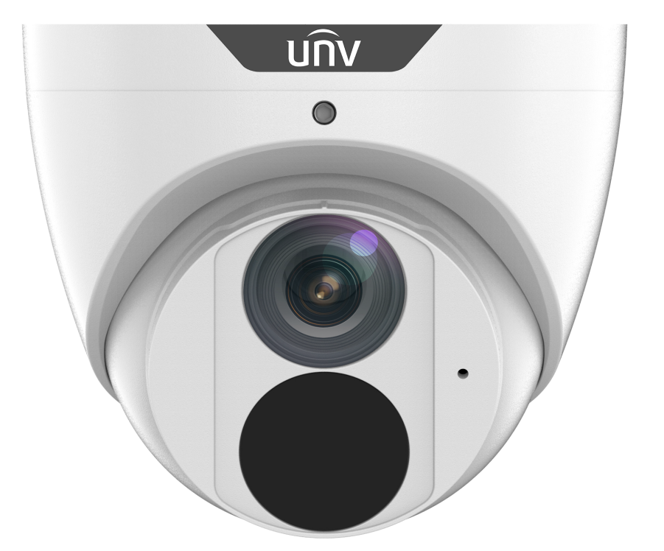

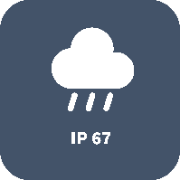
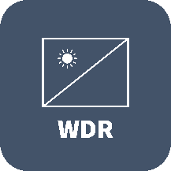





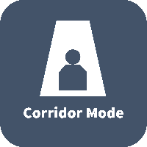
Key Features

- High quality image with 8MP, 1/2.7"CMOS sensor
- 8MP (3840*2160)@20fps; 5MP (3072*1728)@30/25fps; 4MP (2560*1440)@30/25fps; 2MP (1920*1080) @30/25fps
- Ultra 265, H.265, H.264, MJPEG
- Intelligent perimeter protection, include cross line, intrusion, enter area, leave area detection
- Based on target classification, smart intrusion prevention significantly reduce false alarm caused by leaves, birds and lights etc., accurately focus on human and, motor vehicle and non-motor vehicle
- Intelligent People Flow Counting and Crowd Density Monitoring
- 120dB true WDR technology enables clear image in strong light scene
- Support 9:16 Corridor Mode
- Built-in Mic
- Smart IR, up to 30m (98ft) IR distance
- Supports 256 G Micro SD card
- IP67 protection

Specifications
 | IPC3618SB-ADF28KM-I0 |  |  |  |  | IPC3618SB-ADF40KM-I0
Camera
Sensor | 1/2.7", 8.0 megapixel, progressive scan, CMOS
Minimum Illumination | Colour: 0.0025 lux (F1.6, AGC ON)  0 lux with IR on
Day/Night | IR-cut filter with auto switch (ICR)
Shutter | Auto/Manual, 1 ~ 1/100000s
Adjustment angle | Pan: 3° ~ 360° |  | Tilt: 0° ~ 80° |  |  |  |  | Rotate: 3° ~ 360°
WDR | 120dB
S/N | >56dB
Lens
Lens | 2.8mm@F1.6 |  |  |  | 4.0mm@F1.6
Iris | Fixed
Field of View (H) | 112.4° |  |  |  | 86.5°
Field of View (V) | 60.1° |  |  |  | 44.1°
Field of View (D) | 146.1° |  |  |  | 112.5°
DORI
DORI Distance | Lens (mm) | Detect (m) |  | Observe (m) |  |  | Recognize (m) |  | Identify (m)
DORI Distance | 2.8 | 84.0 |  | 33.6 |  |  | 16.8 |  | 8.4
DORI Distance | 4.0 | 120.0 |  | 48.0 |  |  | 24.0 |  | 12.0
Illuminator
IR Range | Up to 30m (98 ft) IR range
Wavelength | 850nm
IR On/Off Control | Auto/Manual
Video
Video Compression | Ultra 265, H.265, H.264, MJPEG
H.264 code profile | Baseline profile, Main profile, High profile
Frame Rate | Main Stream: 8MP (3840*2160), Max 20fps; 5MP (3072*1728), Max 30fps; 4MP (2560*1440), Max 30fps; 1080P (1920*1080), Max 30fps;  Sub Stream: 1080P (1920*1080), Max 30fps;720P (1280*720), Max 30fps; D1 (720*576), Max 30fps; 640*360,Max 30fps; 2CIF(704*288), Max 30fps; CIF(352*288), Max 30fps;  Third Stream: D1 (720*576), Max 30fps; 640*360,Max 30fps; 2CIF(704*288), Max 30fps; CIF(352*288), Max 30fps;
Video Bit Rate | 128 Kbps~16 Mbps
U-code | Support
OSD | Up to 8 OSDs
Privacy Mask | Up to 4 areas
ROI | Up to 8 areas
Video Stream | Triple streams
Image
White Balance | Auto/Outdoor/Fine Tune/Sodium Lamp/Locked/Auto2
Image Setting | Image rotation, brightness, saturation, contrast, sharpness, gain adjustable by web browser
Digital Noise Reduction | 2D/3D DNR
Smart IR | Support
Flip | Normal/Vertical/Horizontal/180°/90°Clockwise/90°Anti-clockwise
Dewarping | Support
HLC | Support
BLC | Support
Defog | Digital Defog
Intelligent
Smart intrusion prevention | Support false alarm filtering: Cross Line detection, Intrusion detection, Enter Area detection, Leave Area detection
Statistical Analysis | People counting, support people flow counting and crowd density monitoring
Events
Basic Detection | Motion detection, Ultra motion detection, Tampering alarm, Audio detection
General Function | Watermark, IP address filtering, tampering alarm, access policy, ARP protection, RTSP authentication, user authentication
Audio
Audio Compression | G.711
Audio Bitrate | 64 Kbps
Suppression | Support
Sampling Rate | 8KHZ
Storage
Edge Storage | Micro SD, up to 256GB
Network Storage | ANR, NAS(NFS)
Network
Protocols | IPv4, IPv6, IGMP, ICMP, ARP, TCP, UDP, DHCP, PPPoE, RTP, RTSP, RTCP, DNS, DDNS, NTP, FTP, UPnP, HTTP, HTTPS, SMTP, 802.1x, SNMP, QoS, RTMP,SSL/TLS, SSH
Compatible Integration | ONVIF (Profile S, Profile G, Profile T), API,SDK
User/Host | Up to 32 users. 3 user levels: administrator, common user, operator
Security | Password protection, Strong password, HTTPS encryption, Export operation logs, Basic and digest authentication for RTSP, Digest authentication for HTTP, TLS 1.2, WSSE and digest authentication for ONVIF
Client | EZStation  EZView  EZLive
Web Browser | Plug-in required live view: IE 10 and above, Chrome 45 and above, Firefox 52 and above, Edge 79 and above
Web Browser | Plug-in free live view: Chrome 57.0 and above, Firefox 58.0 and above, Edge 16 and above
Interface
Audio I/O | N/A
Alarm I/O | N/A
RS485 | N/A
Built-in Mic | Support
Built-in Speaker | N/A
WIFI | N/A
Network | 1 * RJ45 10M/100M Base-TX Ethernet
Video Output | N/A
Certifications
EMC | CE-EMC (EN 55032: 2015+A1:2020,EN 61000-3-3: 2013+A1: 2019,EN IEC 61000-3-2: 2019+A1: 2021,EN 55035: 2017+A11:2020)  FCC (FCC CFR 47 part15 B, ANSI C63.4-2014)
Safety | CE LVD (EN 62368-1:2014+A11:2017)  CB (IEC 62368-1:2014)  UL (UL 62368-1, 2nd Ed., Issue Date: 2014-12-01)
Environment | CE-RoHS (2011/65/EU;(EU)2015/863); WEEE (2012/19/EU); Reach (Regulation (EC) No 1907/2006)
Protection | IP67 (IEC 60529:1989+AMD1:1999+AMD2:2013)
General
Power | DC 12V±25%, PoE (IEEE 802.3af)
Power | Power consumption: Max 5.0W
Power Interface | Ø 5.5mm coaxial power plug
Dimensions (L × W × H) | Φ110.5 x 94.1mm (Φ4.4” x 3.7”)
Weight | 0.44kg (0.97lb)
Material | Metal
Working Environment | -30°C ~ 60°C (-22°F ~ 140°F), Humidity: ≤95% RH (non-condensing)
Strorage Environment | -30°C ~ 60°C (-22°F ~ 140°F), Humidity: ≤95% RH (non-condensing)
Surge Protection | 4KV
Reset Button | N/A

Dimensions
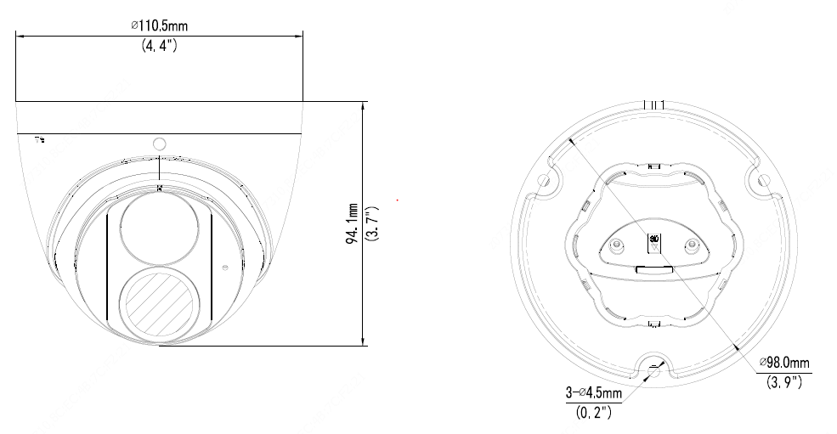

Accessories
TR-JB03-G-IN | TR-JB07/WM03-G-IN | TR-WM03-D-IN | TR-UM06-E-IN
Junction Box | Wall Mount | Wall Mount | Incline Ceiling Mount
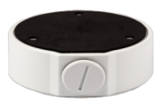 | 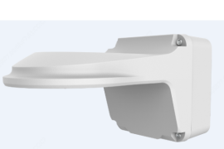 | 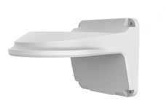 | 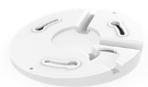
TR-UP06-IN | TR-A01-IN | TR-SE24-IN | TR-SE24-A-IN
Pole Mount | Waterproof Joint | Pendant Mount | Pendant Mount
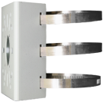 | 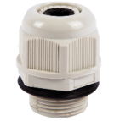 | 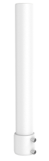 | 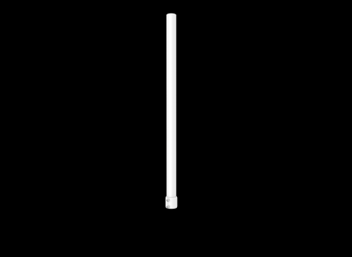
TR-CM24-IN
Pendant Mount
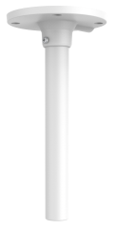

Junction Mount | Pole Mount
TR-JB03-G-IN | TR-JB07/WM03-G-IN
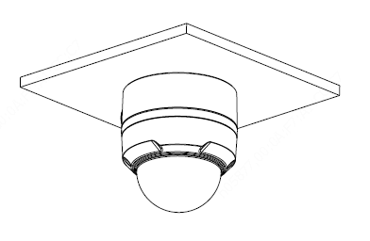 | 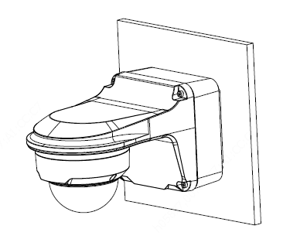
TR-UM06-E-IN | TR-JB07/WM03-G-IN+TR-UP06-IN
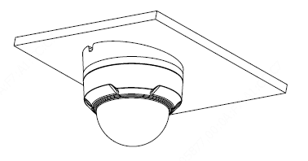 | 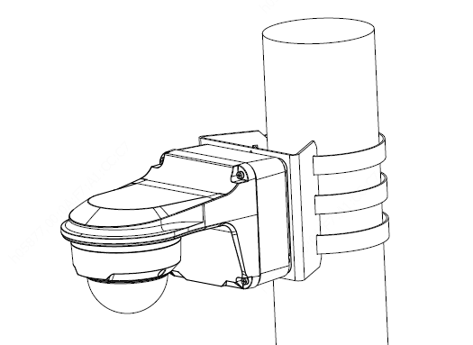
TR-CM24-IN+TR-JB03-G-IN
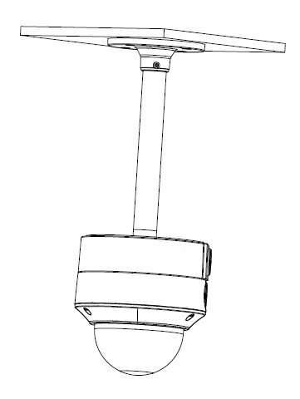

Zhejiang Uniview Technologies Co., Ltd.
Building No.10, Wanlun Science Park, Jiangling Road 88, Binjiang District, Hangzhou, Zhejiang, China (310051)
Email: overseasbusiness@uniview.com; globalsupport@uniview.com
http://www.uniview.com
©2020-2022 Zhejiang Uniview Technologies Co., Ltd. All rights reserved.
*Product specifications and availability are subject to change without notice.

